**CSS Grid Layout**

Important CSS Grid terminology

**Grid Container**

The element on which display: grid is applied. It’s the direct parent of all the grid items. In this example container is the grid container.

<div class="container">

<div class="item item-1"> </div>

<div class="item item-2"> </div>

<div class="item item-3"> </div>

</div>

**Grid Line**

The dividing lines that make up the structure of the grid. They can be either vertical (“column grid lines”) or horizontal (“row grid lines”) and reside on either side of a row or column. Here the yellow line is an example of a column grid line.

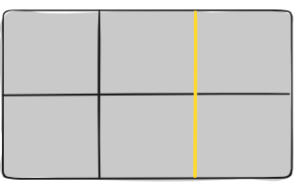

**Grid Track**

The space between two adjacent grid lines. You can think of them as the columns or rows of the grid. Here’s the grid track between the second and third-row grid lines.

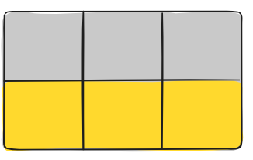

**Grid Area**

The total space is surrounded by four grid lines. A grid area may be composed of any number of grid cells. Here’s the grid area between row grid lines 1 and 3, and column grid lines 1 and 3.

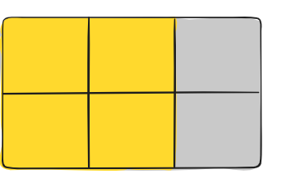

#### Grid Item

The children (i.e. direct descendants) of the grid container. Here the item elements are grid items, but sub-item isn’t.

<div class="container">

<div class="item"> </div>

<div class="item">

<p class="sub-item"> </p>

</div>

<div class="item"> </div>

</div>

#### Grid Cell

The space between two adjacent row and two adjacent column grid lines. It’s a single “unit” of the grid. Here’s the grid cell between row grid lines 1 and 2, and column grid lines 2 and 3

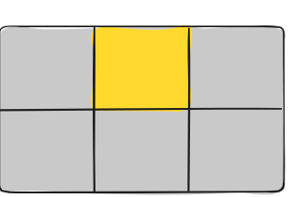

**All CSS Grid Properties**

Property Description

column-gap - Specifies the gap between the columns

gap - A shorthand property for the row-gap and the column-gap properties

grid - A shorthand property for the grid-template-rows, grid-template-columns, grid-template-areas, grid-auto-rows, grid-auto-columns, and the grid-auto-flow properties

grid-area - Either specifies a name for the grid item, or this property is a shorthand property for the grid-row-start, grid-column-start, grid-row-end, and grid-column-end properties

grid-auto-columns - Specifies a default column size

grid-auto-flow - Specifies how auto-placed items are inserted in the grid

grid-auto-rows - Specifies a default row size

grid-column - A shorthand property for the grid-column-start and the grid-column-end properties

grid-column-end - Specifies where to end the grid item

grid-column-gap - Specifies the size of the gap between columns

grid-column-start - Specifies where to start the grid item

grid-gap - A shorthand property for the grid-row-gap and grid-column-gap properties

grid-row - A shorthand property for the grid-row-start and the grid-row-end properties

grid-row-end - Specifies where to end the grid item

grid-row-gap - Specifies the size of the gap between rows

grid-row-start - Specifies where to start the grid item

grid-template - A shorthand property for the grid-template-rows, grid-template-columns and grid-areas properties

grid-template-areas - Specifies how to display columns and rows, using named grid items

grid-template-columns - Specifies the size of the columns, and how many columns in a grid layout

grid-template-rows - Specifies the size of the rows in a grid layout

row-gap - Specifies the gap between the grid rows

#### Properties for the Parent (Grid Container)

#### display

Defines the element as a grid container and establishes a new grid formatting context for its contents.

Values:

* **grid** – generates a block-level grid
* **inline-grid** – generates an inline-level grid

.container {

display: grid | inline-grid;

}

The ability to pass grid parameters down through nested elements (aka subgrids) has been moved to [level 2 of the CSS Grid specification.](https://www.w3.org/TR/css-grid-2/#subgrids) Here’s [a quick explanation](https://css-tricks.com/grid-level-2-and-subgrid/).

#### grid-template-columns grid-template-rows

Defines the columns and rows of the grid with a space-separated list of values. The values represent the track size, and the space between them represents the grid line.

Values:

* **<track-size>** – can be a length, a percentage, or a fraction of the free space in the grid using the [fr](https://css-tricks.com/introduction-fr-css-unit/) unit ([more on this unit](https://www.digitalocean.com/community/tutorials/css-css-grid-layout-fr-unit?utm_medium=content_acq&utm_source=css-tricks&utm_campaign=&utm_content=awareness_bestsellers) over at DigitalOcean)
* **<line-name>** – an arbitrary name of your choosing

.container {

grid-template-columns: ... ...;

*/* e.g.*

*1fr 1fr*

*minmax(10px, 1fr) 3fr*

*repeat(5, 1fr)*

*50px auto 100px 1fr*

*\*/*

grid-template-rows: ... ...;

*/* e.g.*

*min-content 1fr min-content*

*100px 1fr max-content*

*\*/*

}

Grid lines are automatically assigned positive numbers from these assignments (-1 being an alternate for the very last row).

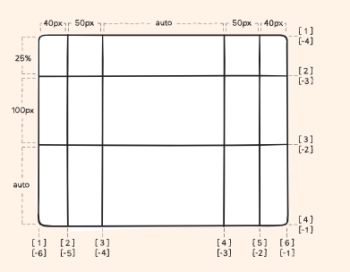

But you can choose to explicitly name the lines. Note the bracket syntax for the line names:

.container {

grid-template-columns: [first] 40px [line2] 50px [line3] auto [col4-start] 50px [five] 40px [end];

grid-template-rows: [row1-start] 25% [row1-end] 100px [third-line] auto [last-line];

}

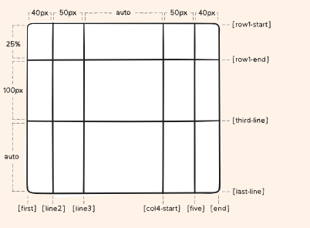

Note that a line can have more than one name. For example, here the second line will have two names: row1-end and row2-start:

.container {

grid-template-rows: [row1-start] 25% [row1-end row2-start] 25% [row2-end];

}

If your definition contains repeating parts, you can use the [repeat() notation](https://www.digitalocean.com/community/tutorials/css-css-grid-layout-repeat-notation?utm_medium=content_acq&utm_source=css-tricks&utm_campaign=&utm_content=awareness_bestsellers) to streamline things:

.container {

grid-template-columns: repeat(3, 20px [col-start]);

}

Which is equivalent to this:

.container {

grid-template-columns: 20px [col-start] 20px [col-start] 20px [col-start];

}

If multiple lines share the same name, they can be referenced by their line name and count.

.item {

grid-column-start: col-start 2;

}

The fr unit allows you to set the size of a track as a fraction of the free space of the grid container. For example, this will set each item to one third the width of the grid container:

.container {

grid-template-columns: 1fr 1fr 1fr;

}

The free space is calculated after any non-flexible items. In this example the total amount of free space available to the fr units doesn’t include the 50px:

.container {

grid-template-columns: 1fr 50px 1fr 1fr;

}

#### grid-template-areas

Defines a grid template by referencing the names of the grid areas which are specified with the [grid-area](https://css-tricks.com/snippets/css/complete-guide-grid/#prop-grid-area) property. Repeating the name of a grid area causes the content to span those cells. A period signifies an empty cell. The syntax itself provides a visualization of the structure of the grid.

Values:

* **<grid-area-name>** – the name of a grid area specified with [grid-area](https://css-tricks.com/snippets/css/complete-guide-grid/#prop-grid-area)
* **.** – a period signifies an empty grid cell
* **none** – no grid areas are defined

.container {

grid-template-areas:

"<grid-area-name> | . | none | ..."

"...";

}

Example:

.item-a {

grid-area: header;

}

.item-b {

grid-area: main;

}

.item-c {

grid-area: sidebar;

}

.item-d {

grid-area: footer;

}

.container {

display: grid;

grid-template-columns: 50px 50px 50px 50px;

grid-template-rows: auto;

grid-template-areas:

"header header header header"

"main main . sidebar"

"footer footer footer footer";

}

That’ll create a grid that’s four columns wide by three rows tall. The entire top row will be composed of the **header** area. The middle row will be composed of two **main** areas, one empty cell, and one **sidebar** area. The last row is all **footer**.

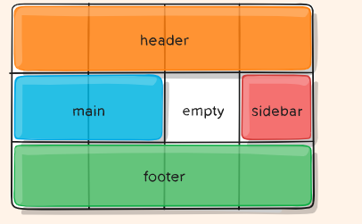

Each row in your declaration needs to have the same number of cells.

You can use any number of adjacent periods to declare a single empty cell. As long as the periods have no spaces between them they represent a single cell.

Notice that you’re not naming lines with this syntax, just areas. When you use this syntax the lines on either end of the areas are actually getting named automatically. If the name of your grid area is **foo**, the name of the area’s starting row line and starting column line will be **foo-start**, and the name of its last row line and last column line will be **foo-end**. This means that some lines might have multiple names, such as the far left line in the above example, which will have three names: header-start, main-start, and footer-start.

#### grid-template

A shorthand for setting [grid-template-rows](https://css-tricks.com/snippets/css/complete-guide-grid/#prop-grid-template-columns-rows), [grid-template-columns](https://css-tricks.com/snippets/css/complete-guide-grid/#prop-grid-template-columns-rows), and [grid-template-areas](https://css-tricks.com/snippets/css/complete-guide-grid/#prop-grid-template-areas) in a single declaration.

Values:

* **none** – sets all three properties to their initial values
* **<grid-template-rows> / <grid-template-columns>** – sets [grid-template-columns](https://css-tricks.com/snippets/css/complete-guide-grid/#prop-grid-template-columns-rows) and [grid-template-rows](https://css-tricks.com/snippets/css/complete-guide-grid/#prop-grid-template-columns-rows) to the specified values, respectively, and sets [grid-template-areas](https://css-tricks.com/snippets/css/complete-guide-grid/#prop-grid-template-areas) to none

.container {

grid-template: none | <grid-template-rows> / <grid-template-columns>;

}

It also accepts a more complex but quite handy syntax for specifying all three. Here’s an example:

.container {

grid-template:

[row1-start] "header header header" 25px [row1-end]

[row2-start] "footer footer footer" 25px [row2-end]

/ auto 50px auto;

}

That’s equivalent to this:

.container {

grid-template-rows: [row1-start] 25px [row1-end row2-start] 25px [row2-end];

grid-template-columns: auto 50px auto;

grid-template-areas:

"header header header"

"footer footer footer";

}

Since grid-template doesn’t reset the implicit grid properties ([grid-auto-columns](https://css-tricks.com/snippets/css/complete-guide-grid/#prop-grid-auto-columns-rows), [grid-auto-rows](https://css-tricks.com/snippets/css/complete-guide-grid/#prop-grid-auto-columns-rows), and [grid-auto-flow](https://css-tricks.com/snippets/css/complete-guide-grid/#prop-grid-auto-flow)), which is probably what you want to do in most cases, it’s recommended to use the [grid](https://css-tricks.com/snippets/css/complete-guide-grid/#prop-grid) property instead of grid-template.

#### column-gap row-gap grid-column-gap grid-row-gap

Specifies the size of the grid lines. You can think of it like setting the width of the gutters between the columns/rows.

Values:

* **<line-size>** – a length value

.container {

*/* standard */*

column-gap: <line-size>;

row-gap: <line-size>;

*/* old */*

grid-column-gap: <line-size>;

grid-row-gap: <line-size>;

}

Example:

.container {

grid-template-columns: 100px 50px 100px;

grid-template-rows: 80px auto 80px;

column-gap: 10px;

row-gap: 15px;

}

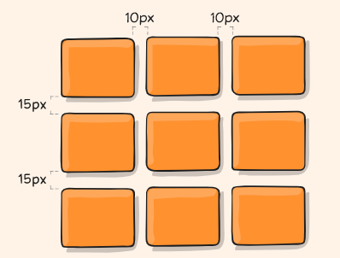

The gutters are only created between the columns/rows, not on the outer edges.

Note: The grid- prefix will be removed and grid-column-gap and grid-row-gap renamed to column-gap and row-gap. The unprefixed properties are already supported in Chrome 68+, Safari 11.2 Release 50+, and Opera 54+.

#### gap grid-gap

A shorthand for [row-gap](https://css-tricks.com/snippets/css/complete-guide-grid/#prop-grid-column-row-gap) and [column-gap](https://css-tricks.com/snippets/css/complete-guide-grid/#prop-grid-column-row-gap)

Values:

* **<grid-row-gap> <grid-column-gap>** – length values

.container {

*/* standard */*

gap: <grid-row-gap> <grid-column-gap>;

*/* old */*

grid-gap: <grid-row-gap> <grid-column-gap>;

}

Example:

.container {

grid-template-columns: 100px 50px 100px;

grid-template-rows: 80px auto 80px;

gap: 15px 10px;

}

If no [row-gap](https://css-tricks.com/snippets/css/complete-guide-grid/#prop-grid-column-row-gap) is specified, it’s set to the same value as [column-gap](https://css-tricks.com/snippets/css/complete-guide-grid/#prop-grid-column-row-gap)

**Note**: The grid- prefix is deprecated (but who knows, may never actually be removed from browsers). Essentially grid-gap renamed to gap. The unprefixed property is already supported in Chrome 68+, Safari 11.2 Release 50+, and Opera 54+.

#### justify-items

Aligns grid items along the inline (row) axis (as opposed to [align-items](https://css-tricks.com/snippets/css/complete-guide-grid/#prop-align-items) which aligns along the block (column) axis). This value applies to all grid items inside the container.

Values:

* **start** – aligns items to be flush with the start edge of their cell
* **end** – aligns items to be flush with the end edge of their cell
* **center** – aligns items in the center of their cell
* **stretch** – fills the whole width of the cell (this is the default)

.container {

justify-items: start | end | center | stretch;

}

Examples:

.container {

justify-items: start;

}

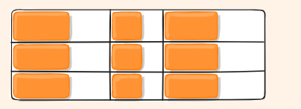

.container {

justify-items: end;

}

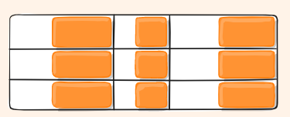

.container {

justify-items: center;

}

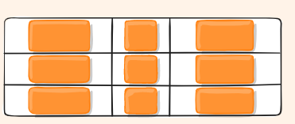

.container {

justify-items: stretch;

}

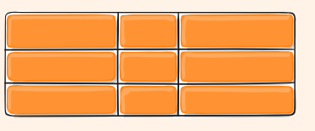

This behavior can also be set on individual grid items via the [justify-self](https://css-tricks.com/snippets/css/complete-guide-grid/#prop-justify-self) property.

#### align-items

Aligns grid items along the block (column) axis (as opposed to [justify-items](https://css-tricks.com/snippets/css/complete-guide-grid/#prop-justify-items) which aligns along the inline (row) axis). This value applies to all grid items inside the container.

Values:

* **stretch** – fills the whole height of the cell (this is the default)
* **start** – aligns items to be flush with the start edge of their cell
* **end** – aligns items to be flush with the end edge of their cell
* **center** – aligns items in the center of their cell
* **baseline** – align items [along text baseline](https://codepen.io/chriscoyier/pen/NWvvPRj). There are modifiers to baseline — first baseline and last baseline which will use the baseline from the first or last line in the case of multi-line text.

.container {

align-items: start | end | center | stretch;

}

Examples:

.container {

align-items: start;

}

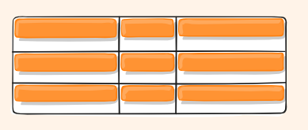

.container {

align-items: end;

}

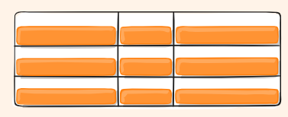

.container {

align-items: center;

}

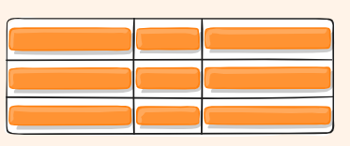

.container {

align-items: stretch;

}

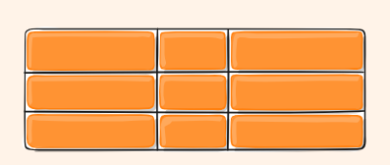

This behavior can also be set on individual grid items via the [align-self](https://css-tricks.com/snippets/css/complete-guide-grid/#prop-align-self) property.

There are also modifier keywords safe and unsafe (usage is like align-items: safe end). The safe keyword means “try to align like this, but not if it means aligning an item such that it moves into inaccessible overflow area”, while unsafe will allow moving content into inaccessible areas (“data loss”).

#### place-items

place-items sets both the align-items and justify-items properties in a single declaration.

Values:

* **<align-items> / <justify-items>** – The first value sets align-items, the second value justify-items. If the second value is omitted, the first value is assigned to both properties.

For more details, see [align-items](https://css-tricks.com/snippets/css/complete-guide-grid/#prop-align-items) and [justify-items](https://css-tricks.com/snippets/css/complete-guide-grid/#prop-justify-items).

This can be very useful for super quick multi-directional centering:

.center {

display: grid;

place-items: center;

}

#### justify-content

Sometimes the total size of your grid might be less than the size of its grid container. This could happen if all of your grid items are sized with non-flexible units like px. In this case you can set the alignment of the grid within the grid container. This property aligns the grid along the inline (row) axis (as opposed to [align-content](https://css-tricks.com/snippets/css/complete-guide-grid/#prop-align-content) which aligns the grid along the block (column) axis).

Values:

* **start** – aligns the grid to be flush with the start edge of the grid container
* **end** – aligns the grid to be flush with the end edge of the grid container
* **center** – aligns the grid in the center of the grid container
* **stretch** – resizes the grid items to allow the grid to fill the full width of the grid container
* **space-around** – places an even amount of space between each grid item, with half-sized spaces on the far ends
* **space-between** – places an even amount of space between each grid item, with no space at the far ends
* **space-evenly** – places an even amount of space between each grid item, including the far ends

.container {

justify-content: start | end | center | stretch | space-around | space-between | space-evenly;

}

Examples:

.container {

justify-content: start;

}

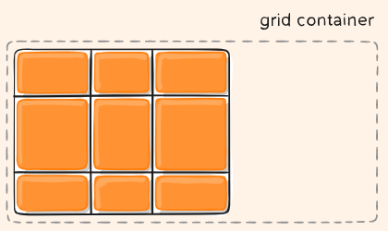

.container {

justify-content: end;

}

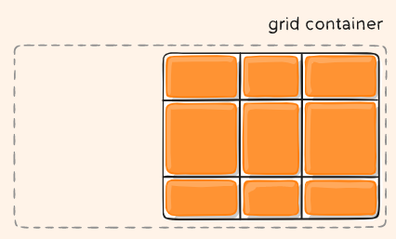

.container {

justify-content: center;

}

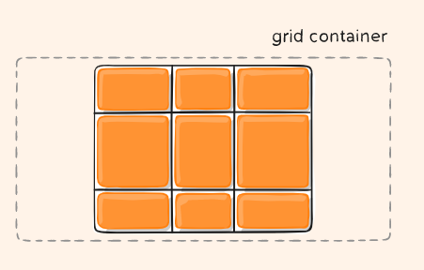

.container {

justify-content: stretch;

}

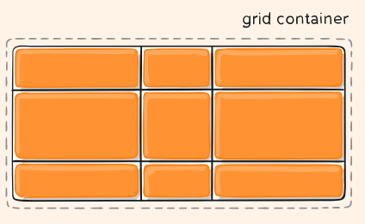

.container {

justify-content: space-around;

}

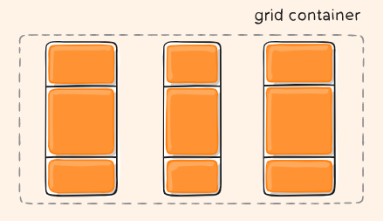

.container {

justify-content: space-between;

}

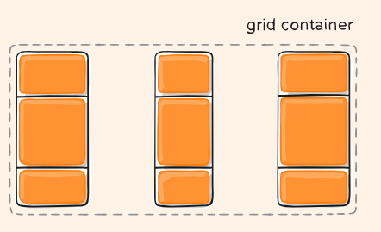

.container {

justify-content: space-evenly;

}

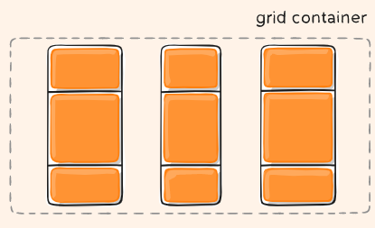

#### align-content

Sometimes the total size of your grid might be less than the size of its grid container. This could happen if all of your grid items are sized with non-flexible units like px. In this case you can set the alignment of the grid within the grid container. This property aligns the grid along the block (column) axis (as opposed to [justify-content](https://css-tricks.com/snippets/css/complete-guide-grid/#prop-justify-content) which aligns the grid along the inline (row) axis).

Values:

* **start** – aligns the grid to be flush with the start edge of the grid container
* **end** – aligns the grid to be flush with the end edge of the grid container
* **center** – aligns the grid in the center of the grid container
* **stretch** – resizes the grid items to allow the grid to fill the full height of the grid container
* **space-around** – places an even amount of space between each grid item, with half-sized spaces on the far ends
* **space-between** – places an even amount of space between each grid item, with no space at the far ends
* **space-evenly** – places an even amount of space between each grid item, including the far ends

.container {

align-content: start | end | center | stretch | space-around | space-between | space-evenly;

}

Examples:

.container {

align-content: start;

}

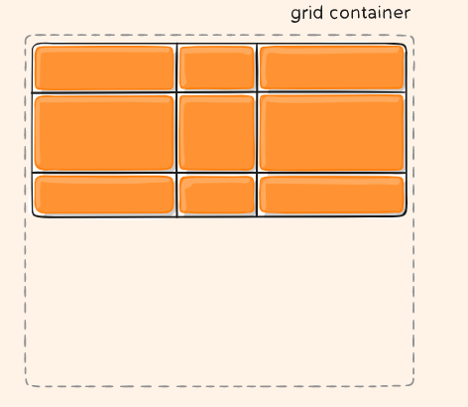

.container {

align-content: end;

}

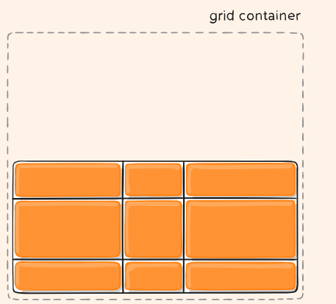

.container {

align-content: center;

}

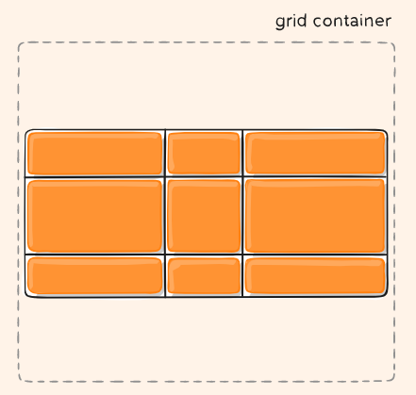

.container {

align-content: stretch;

}

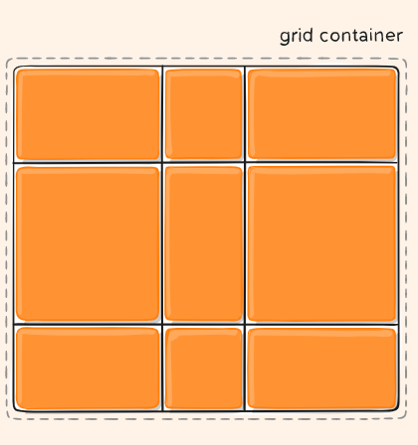

.container {

align-content: space-around;

}

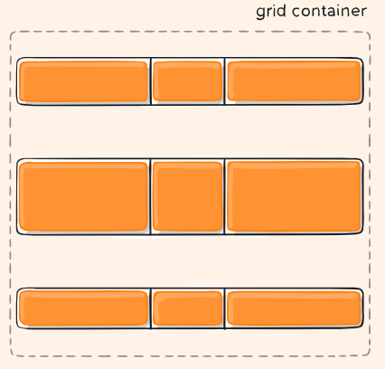

.container {

align-content: space-between;

}

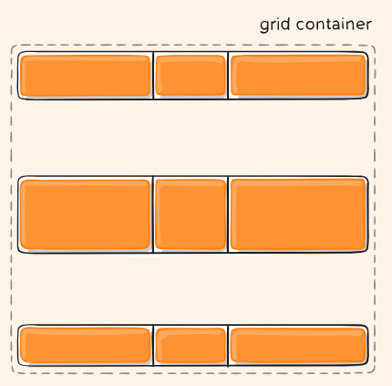

.container {

align-content: space-evenly;

}

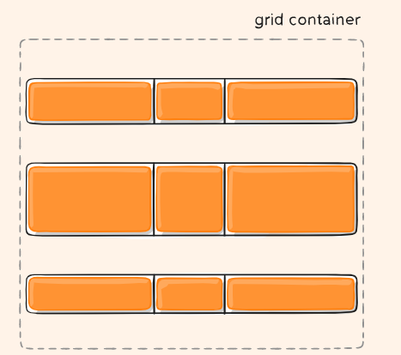

#### place-content

place-content sets both the align-content and justify-content properties in a single declaration.

Values:

* **<align-content> / <justify-content>** – The first value sets align-content, the second value justify-content. If the second value is omitted, the first value is assigned to both properties.

All major browsers except Edge support the place-content shorthand property.

For more details, see [align-content](https://css-tricks.com/snippets/css/complete-guide-grid/#prop-align-content) and [justify-content](https://css-tricks.com/snippets/css/complete-guide-grid/#prop-justify-content).

#### grid-auto-columns grid-auto-rows

Specifies the size of any auto-generated grid tracks (aka implicit grid tracks). Implicit tracks get created when there are more grid items than cells in the grid or when a grid item is placed outside of the explicit grid. (see [The Difference Between Explicit and Implicit Grids](https://css-tricks.com/difference-explicit-implicit-grids/))

Values:

* **<track-size>** – can be a length, a percentage, or a fraction of the free space in the grid (using the [fr](https://css-tricks.com/snippets/css/complete-guide-grid/" \l "fr-unit) unit)

.container {

grid-auto-columns: <track-size> ...;

grid-auto-rows: <track-size> ...;

}

To illustrate how implicit grid tracks get created, think about this:

.container {

grid-template-columns: 60px 60px;

grid-template-rows: 90px 90px;

}

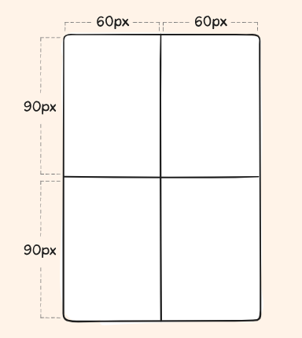

This creates a 2 x 2 grid.

But now imagine you use [grid-column](https://css-tricks.com/snippets/css/complete-guide-grid/#prop-grid-column-row) and [grid-row](https://css-tricks.com/snippets/css/complete-guide-grid/#prop-grid-column-row) to position your grid items like this:

.item-a {

grid-column: 1 / 2;

grid-row: 2 / 3;

}

.item-b {

grid-column: 5 / 6;

grid-row: 2 / 3;

}

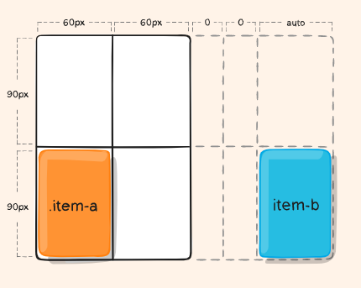

We told .item-b to start on column line 5 and end at column line 6, but we never defined a column line 5 or 6. Because we referenced lines that don’t exist, implicit tracks with widths of 0 are created to fill in the gaps. We can use [grid-auto-columns](https://css-tricks.com/snippets/css/complete-guide-grid/#prop-grid-auto-columns-rows) and [grid-auto-rows](https://css-tricks.com/snippets/css/complete-guide-grid/#prop-grid-auto-columns-rows) to specify the widths of these implicit tracks:

.container {

grid-auto-columns: 60px;

}

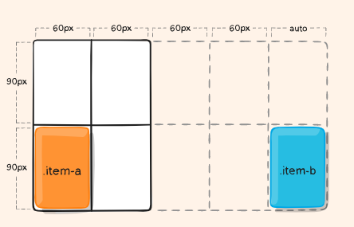

#### grid-auto-flow

If you have grid items that you don’t explicitly place on the grid, the auto-placement algorithm kicks in to automatically place the items. This property controls how the auto-placement algorithm works.

Values:

* **row** – tells the auto-placement algorithm to fill in each row in turn, adding new rows as necessary (default)
* **column** – tells the auto-placement algorithm to fill in each column in turn, adding new columns as necessary
* **dense** – tells the auto-placement algorithm to attempt to fill in holes earlier in the grid if smaller items come up later

.container {

grid-auto-flow: row | column | row dense | column dense;

}

Note that **dense** only changes the visual order of your items and might cause them to appear out of order, which is bad for accessibility.

Examples:

Consider this HTML:

<section class="container">

<div class="item-a">item-a</div>

<div class="item-b">item-b</div>

<div class="item-c">item-c</div>

<div class="item-d">item-d</div>

<div class="item-e">item-e</div>

</section>

You define a grid with five columns and two rows, and set grid-auto-flow to row (which is also the default):

.container {

display: grid;

grid-template-columns: 60px 60px 60px 60px 60px;

grid-template-rows: 30px 30px;

grid-auto-flow: row;

}

When placing the items on the grid, you only specify spots for two of them:

.item-a {

grid-column: 1;

grid-row: 1 / 3;

}

.item-e {

grid-column: 5;

grid-row: 1 / 3;

}

Because we set grid-auto-flow to row, our grid will look like this. Notice how the three items we didn’t place (**item-b**, **item-c** and **item-d**) flow across the available rows:

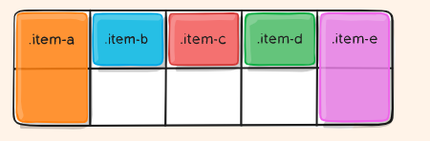

If we instead set grid-auto-flow to column, **item-b**, **item-c** and **item-d** flow down the columns:

.container {

display: grid;

grid-template-columns: 60px 60px 60px 60px 60px;

grid-template-rows: 30px 30px;

grid-auto-flow: column;

}

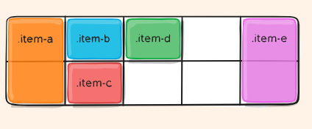

#### grid

A shorthand for setting all of the following properties in a single declaration: [grid-template-rows](https://css-tricks.com/snippets/css/complete-guide-grid/#prop-grid-template-columns-rows), [grid-template-columns](https://css-tricks.com/snippets/css/complete-guide-grid/#prop-grid-template-columns-rows), [grid-template-areas](https://css-tricks.com/snippets/css/complete-guide-grid/#prop-grid-template-areas), [grid-auto-rows](https://css-tricks.com/snippets/css/complete-guide-grid/#prop-grid-auto-columns-rows), [grid-auto-columns](https://css-tricks.com/snippets/css/complete-guide-grid/#prop-grid-auto-columns-rows), and [grid-auto-flow](https://css-tricks.com/snippets/css/complete-guide-grid/#prop-grid-auto-flow) (Note: You can only specify the explicit or the implicit grid properties in a single grid declaration).

Values:

* **none** – sets all sub-properties to their initial values.
* **<grid-template>** – works the same as the [grid-template](https://css-tricks.com/snippets/css/complete-guide-grid/#prop-grid-template) shorthand.
* **<grid-template-rows> / [ auto-flow && dense? ] <grid-auto-columns>?** – sets [grid-template-rows](https://css-tricks.com/snippets/css/complete-guide-grid/#prop-grid-template-columns-rows) to the specified value. If the auto-flow keyword is to the right of the slash, it sets [grid-auto-flow](https://css-tricks.com/snippets/css/complete-guide-grid/#prop-grid-auto-flow) to column. If the dense keyword is specified additionally, the auto-placement algorithm uses a “dense” packing algorithm. If [grid-auto-columns](https://css-tricks.com/snippets/css/complete-guide-grid/#prop-grid-auto-columns-rows) is omitted, it is set to auto.
* **[ auto-flow && dense? ] <grid-auto-rows>? / <grid-template-columns>** – sets [grid-template-columns](https://css-tricks.com/snippets/css/complete-guide-grid/#prop-grid-template-columns-rows) to the specified value. If the auto-flow keyword is to the left of the slash, it sets [grid-auto-flow](https://css-tricks.com/snippets/css/complete-guide-grid/#prop-grid-auto-flow) to row. If the dense keyword is specified additionally, the auto-placement algorithm uses a “dense” packing algorithm. If [grid-auto-rows](https://css-tricks.com/snippets/css/complete-guide-grid/#prop-grid-auto-columns-rows) is omitted, it is set to auto.

Examples:

The following two code blocks are equivalent:

.container {

grid: 100px 300px / 3fr 1fr;

}

.container {

grid-template-rows: 100px 300px;

grid-template-columns: 3fr 1fr;

}

The following two code blocks are equivalent:

.container {

grid: auto-flow / 200px 1fr;

}

.container {

grid-auto-flow: row;

grid-template-columns: 200px 1fr;

}

The following two code blocks are equivalent:

.container {

grid: auto-flow dense 100px / 1fr 2fr;

}

.container {

grid-auto-flow: row dense;

grid-auto-rows: 100px;

grid-template-columns: 1fr 2fr;

}

And the following two code blocks are equivalent:

.container {

grid: 100px 300px / auto-flow 200px;

}

.container {

grid-template-rows: 100px 300px;

grid-auto-flow: column;

grid-auto-columns: 200px;

}

It also accepts a more complex but quite handy syntax for setting everything at once. You specify [grid-template-areas](https://css-tricks.com/snippets/css/complete-guide-grid/#prop-grid-template-areas), [grid-template-rows](https://css-tricks.com/snippets/css/complete-guide-grid/#prop-grid-template-columns-rows) and [grid-template-columns](https://css-tricks.com/snippets/css/complete-guide-grid/#prop-grid-template-columns-rows), and all the other sub-properties are set to their initial values. What you’re doing is specifying the line names and track sizes inline with their respective grid areas. This is easiest to describe with an example:

.container {

grid: [row1-start] "header header header" 1fr [row1-end]

[row2-start] "footer footer footer" 25px [row2-end]

/ auto 50px auto;

}

That’s equivalent to this:

.container {

grid-template-areas:

"header header header"

"footer footer footer";

grid-template-rows: [row1-start] 1fr [row1-end row2-start] 25px [row2-end];

grid-template-columns: auto 50px auto;

}

#### Properties for the Children (Grid Items)

#### grid-column-start grid-column-end grid-row-start grid-row-end

Determines a grid item’s location within the grid by referring to specific grid lines. grid-column-start/grid-row-start is the line where the item begins, and grid-column-end/grid-row-end is the line where the item ends.

Values:

* **<line>** – can be a number to refer to a numbered grid line, or a name to refer to a named grid line
* **span <number>** – the item will span across the provided number of grid tracks
* **span <name>** – the item will span across until it hits the next line with the provided name
* **auto** – indicates auto-placement, an automatic span, or a default span of one

.item {

grid-column-start: <number> | <name> | span <number> | span <name> | auto;

grid-column-end: <number> | <name> | span <number> | span <name> | auto;

grid-row-start: <number> | <name> | span <number> | span <name> | auto;

grid-row-end: <number> | <name> | span <number> | span <name> | auto;

}

Examples:

.item-a {

grid-column-start: 2;

grid-column-end: five;

grid-row-start: row1-start;

grid-row-end: 3;

}

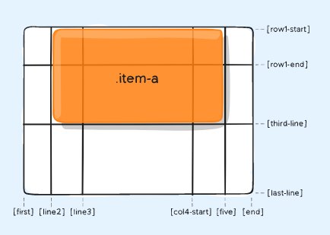

.item-b {

grid-column-start: 1;

grid-column-end: span col4-start;

grid-row-start: 2;

grid-row-end: span 2;

}

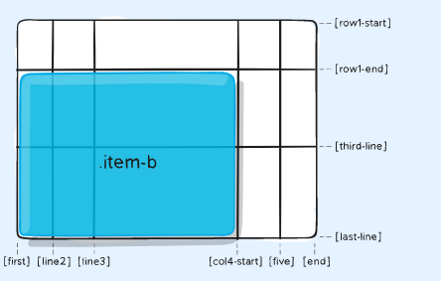

If no grid-column-end/grid-row-end is declared, the item will span 1 track by default.

Items can overlap each other. You can use z-index to control their stacking order.

Learn more about the span notation in [this article by DigitalOcean](https://www.digitalocean.com/community/tutorials/css-css-grid-layout-span-keyword?utm_medium=content_acq&utm_source=css-tricks&utm_campaign=&utm_content=awareness_bestsellers).

#### grid-column grid-row

Shorthand for [grid-column-start](https://css-tricks.com/snippets/css/complete-guide-grid/#prop-grid-column-row-start-end) + [grid-column-end](https://css-tricks.com/snippets/css/complete-guide-grid/#prop-grid-column-row-start-end), and [grid-row-start](https://css-tricks.com/snippets/css/complete-guide-grid/#prop-grid-column-row-start-end) + [grid-row-end](https://css-tricks.com/snippets/css/complete-guide-grid/#prop-grid-column-row-start-end), respectively.

Values:

* **<start-line> / <end-line>** – each one accepts all the same values as the longhand version, including span

.item {

grid-column: <start-line> / <end-line> | <start-line> / span <value>;

grid-row: <start-line> / <end-line> | <start-line> / span <value>;

}

Example:

.item-c {

grid-column: 3 / span 2;

grid-row: third-line / 4;

}

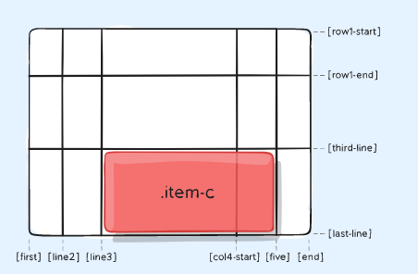

If no end line value is declared, the item will span 1 track by default.

#### grid-area

Gives an item a name so that it can be referenced by a template created with the [grid-template-areas](https://css-tricks.com/snippets/css/complete-guide-grid/#prop-grid-template-areas) property. Alternatively, this property can be used as an even shorter shorthand for [grid-row-start](https://css-tricks.com/snippets/css/complete-guide-grid/#prop-grid-column-row-start-end) + [grid-column-start](https://css-tricks.com/snippets/css/complete-guide-grid/#prop-grid-column-row-start-end) + [grid-row-end](https://css-tricks.com/snippets/css/complete-guide-grid/#prop-grid-column-row-start-end) + [grid-column-end](https://css-tricks.com/snippets/css/complete-guide-grid/#prop-grid-column-row-start-end).

Values:

* **<name>** – a name of your choosing
* **<row-start> / <column-start> / <row-end> / <column-end>** – can be numbers or named lines

.item {

grid-area: <name> | <row-start> / <column-start> / <row-end> / <column-end>;

}

Examples:

As a way to assign a name to the item:

.item-d {

grid-area: header;

}

As the short-shorthand for [grid-row-start](https://css-tricks.com/snippets/css/complete-guide-grid/#prop-grid-column-row-start-end) + [grid-column-start](https://css-tricks.com/snippets/css/complete-guide-grid/#prop-grid-column-row-start-end) + [grid-row-end](https://css-tricks.com/snippets/css/complete-guide-grid/#prop-grid-column-row-start-end) + [grid-column-end](https://css-tricks.com/snippets/css/complete-guide-grid/#prop-grid-column-row-start-end):

.item-d {

grid-area: 1 / col4-start / last-line / 6;

}

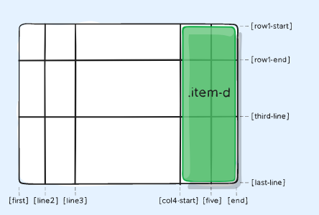

#### justify-self

Aligns a grid item inside a cell along the inline (row) axis (as opposed to [align-self](https://css-tricks.com/snippets/css/complete-guide-grid/#prop-align-self) which aligns along the block (column) axis). This value applies to a grid item inside a single cell.

Values:

* **start** – aligns the grid item to be flush with the start edge of the cell
* **end** – aligns the grid item to be flush with the end edge of the cell
* **center** – aligns the grid item in the center of the cell
* **stretch** – fills the whole width of the cell (this is the default)

.item {

justify-self: start | end | center | stretch;

}

Examples:

.item-a {

justify-self: start;

}

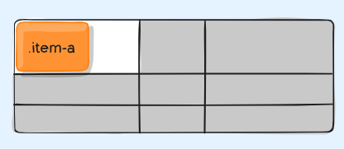

.item-a {

justify-self: end;

}

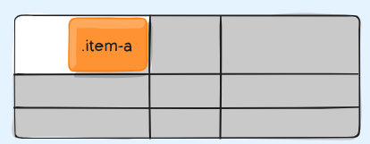

.item-a {

justify-self: center;

}

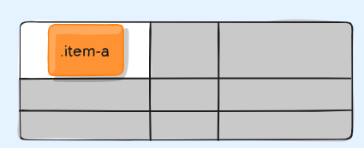

.item-a {

justify-self: stretch;

}

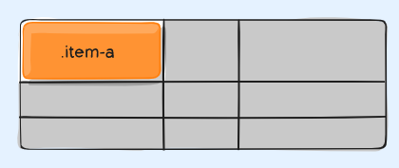

To set alignment for all the items in a grid, this behavior can also be set on the grid container via the [justify-items](https://css-tricks.com/snippets/css/complete-guide-grid/#prop-justify-items) property.

#### align-self

Aligns a grid item inside a cell along the block (column) axis (as opposed to [justify-self](https://css-tricks.com/snippets/css/complete-guide-grid/#prop-justify-self) which aligns along the inline (row) axis). This value applies to the content inside a single grid item.

Values:

* **start** – aligns the grid item to be flush with the start edge of the cell
* **end** – aligns the grid item to be flush with the end edge of the cell
* **center** – aligns the grid item in the center of the cell
* **stretch** – fills the whole height of the cell (this is the default)

.item {

align-self: start | end | center | stretch;

}

Examples:

.item-a {

align-self: start;

}

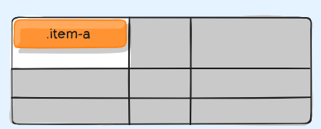

.item-a {

align-self: end;

}

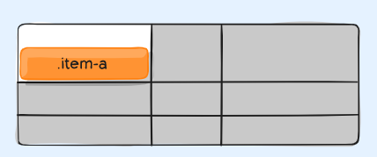

.item-a {

align-self: center;

}

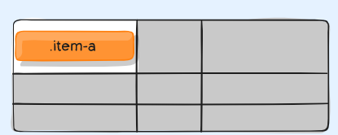

.item-a {

align-self: stretch;

}

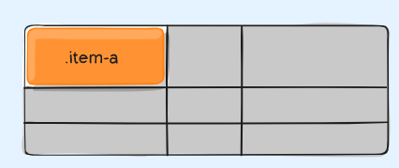

To align all the items in a grid, this behavior can also be set on the grid container via the [align-items](https://css-tricks.com/snippets/css/complete-guide-grid/#prop-align-items) property.

#### place-self

place-self sets both the align-self and justify-self properties in a single declaration.

Values:

* **auto** – The “default” alignment for the layout mode.
* **<align-self> / <justify-self>** – The first value sets align-self, the second value justify-self. If the second value is omitted, the first value is assigned to both properties.

Examples:

.item-a {

place-self: center;

}

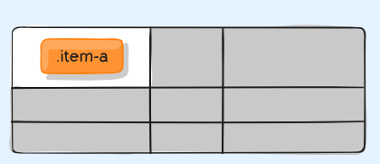

.item-a {

place-self: center stretch;

}

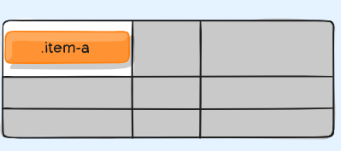

All major browsers except Edge support the place-self shorthand property.

## Special Units & Functions

#### fr units

You’ll likely end up using a lot of [fractional units](https://css-tricks.com/introduction-fr-css-unit/) in CSS Grid, like 1fr. They essentially mean “portion of the remaining space”. So a declaration like:

grid-template-columns: 1fr 3fr;

Means, loosely, 25% 75%. Except that those percentage values are much more firm than fractional units are. For example, if you added padding to those percentage-based columns, now you’ve broken 100% width (assuming a content-box box model). Fractional units also much more friendly in combination with other units, as you can imagine:

grid-template-columns: 50px min-content 1fr;

#### Sizing Keywords

When sizing rows and columns, you can use all the [lengths](https://css-tricks.com/the-lengths-of-css/) you are used to, like px, rem, %, etc, but you also have keywords:

* min-content: the minimum size of the content. Imagine a line of text like “E pluribus unum”, the min-content is likely the width of the word “pluribus”.
* max-content: the maximum size of the content. Imagine the sentence above, the max-content is the length of the whole sentence.
* auto: this keyword is a lot like fr units, except that they “lose” the fight in sizing against fr units when allocating the remaining space.
* Fractional units: see above

#### Sizing Functions

* The fit-content() function uses the space available, but never less than min-content and never more than max-content.
* The minmax() function does exactly what it seems like: it sets a minimum and maximum value for what the length is able to be. This is useful for in combination with relative units. Like you may want a column to be only able to shrink so far. This is [extremely useful and probably what you want](https://css-tricks.com/you-want-minmax10px-1fr-not-1fr/):

grid-template-columns: minmax(100px, 1fr) 3fr;

* The min() function.
* The max() function.

#### The repeat() Function and Keywords

The repeat() function can save some typing:

grid-template-columns:

1fr 1fr 1fr 1fr 1fr 1fr 1fr 1fr;

*/* easier: */*

grid-template-columns:

repeat(8, 1fr);

*/* especially when: */*

grid-template-columns:

repeat(8, minmax(10px, 1fr));

But repeat() can get extra fancy when combined with keywords:

* auto-fill: Fit as many possible columns as possible on a row, even if they are empty.
* auto-fit: Fit whatever columns there are into the space. Prefer expanding columns to fill space rather than empty columns.

This bears the most famous snippet in all of CSS Grid and one of the [all-time great CSS tricks](https://css-tricks.com/books/greatest-css-tricks/flexible-grids/):

grid-template-columns:

repeat(auto-fit, minmax(250px, 1fr));

The difference between the keywords is [spelled out in detail here](https://css-tricks.com/auto-sizing-columns-css-grid-auto-fill-vs-auto-fit/).

#### Masonry

An experimental feature of CSS grid is masonry layout. Note that there are [lots of approaches to CSS masonry](https://css-tricks.com/piecing-together-approaches-for-a-css-masonry-layout/), but mostly of them are trickery and either have major downsides or aren’t what you quite expect.

[The spec has an official way](https://drafts.csswg.org/css-grid-3/#masonry-layout) now, and this is behind a flag in Firefox:

.container {

display: grid;

grid-template-columns: repeat(4, 1fr);

grid-template-rows: masonry;

}

[See Rachel’s article](https://www.smashingmagazine.com/native-css-masonry-layout-css-grid/) for a deep dive.

#### Subgrid

Subgrid is an extremely useful feature of grids that allows grid items to have a grid of their own that inherits grid lines from the parent grid.

.parent-grid {

display: grid;

grid-template-columns: repeat(9, 1fr);

}

.grid-item {

grid-column: 2 / 7;

display: grid;

grid-template-columns: subgrid;

}

.child-of-grid-item {

*/* gets to participate on parent grid! */*

grid-column: 3 / 6;

}

This is [only supported in Firefox](https://developer.mozilla.org/en-US/docs/Web/CSS/CSS_Grid_Layout/Subgrid#browser_compatibility) right now, but it really [needs](http://meyerweb.com/eric/thoughts/2016/01/15/subgrids-considered-essential/) to get everywhere.

It’s also useful to know about display: contents;. This is not the same as subgrid, but it can be a useful tool sometimes in a similar fashion.

<div class="grid-parent">

<div class="grid-item"></div>

<div class="grid-item"></div>

<ul style="display: contents;">

*<!-- These grid-items get to participate on*

*the same grid!-->*

<li class="grid-item"></li>

<li class="grid-item"></li>

</ul>

</div>

**CSS Grid columns/row – start and end element**

Grid-column-start

Grid-column-end

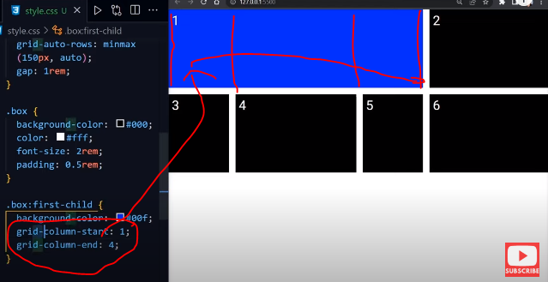

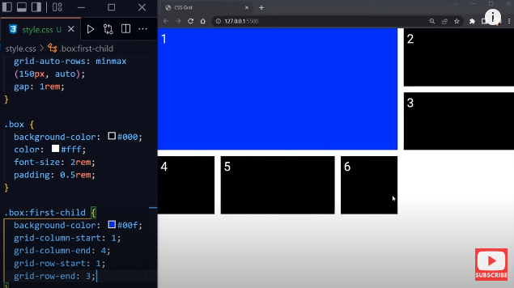

Start and end grid shorthand:

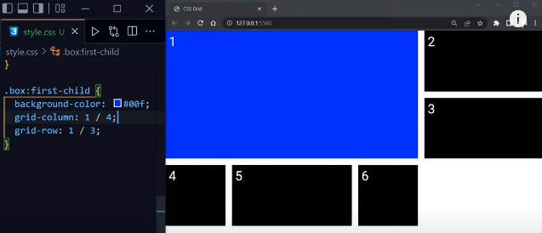

With nth-child(number):

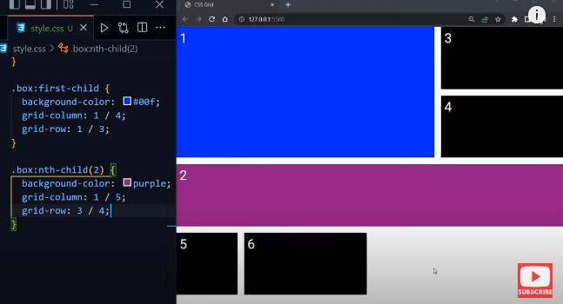

**Shorthand for align-content & justify content**

Place-content: align-content justify-content;

Example:

Place-content: end center;

**Fluid columns snippet**

Fluid width columns that break into more or less columns as space is available, with no media queries!

.grid {

display: grid;

grid-template-columns: repeat(auto-fill, minmax(200px, 1fr));

*/* This is better for small screens, once min() is better supported */*

*/* grid-template-columns: repeat(auto-fill, minmax(min(200px, 100%), 1fr)); */*

gap: 1rem;

}

grid-template shorthand

The grid-template CSS property is a shorthand property for defining grid columns, grid rows,

and grid areas.

**Constituent properties**

This property is a shorthand for the following CSS properties:

grid-template-areas

grid-template-columns

grid-template-rows

**Syntax**

/* Keyword value */

grid-template: none;

/* grid-template-rows / grid-template-columns values */

grid-template: 100px 1fr / 50px 1fr;

grid-template: auto 1fr / auto 1fr auto;

grid-template: [linename] 100px / [columnname1] 30% [columnname2] 70%;

grid-template: fit-content(100px) / fit-content(40%);

/* grid-template-areas grid-template-rows / grid-template-column values */

grid-template:

"a a a"

"b b b";

grid-template:

"a a a" 20%

"b b b" auto;

grid-template:

[header-top] "a a a" [header-bottom]

[main-top] "b b b" 1fr [main-bottom]

/ auto 1fr auto;

/* Global values */

grid-template: inherit;

grid-template: initial;

grid-template: revert;

grid-template: revert-layer;

grid-template: unset;

**Values**

none

Is a keyword that sets all three longhand properties to none, meaning there is no explicit grid. There are no named grid areas. Rows and columns will be implicitly generated; their size will be determined by the grid-auto-rows and grid-auto-columns properties.

<'grid-template-rows'> / <'grid-template-columns'>

Sets grid-template-rows and grid-template-columns to the specified values, and sets grid-template-areas to none.

[ <line-names>? <string> <track-size>? <line-names>? ]+ [ / <explicit-track-list> ]?

Sets grid-template-areas to the strings listed, grid-template-rows to the track sizes following each string (filling in auto for any missing sizes), and splicing in the named lines defined before/after each size, and grid-template-columns to the track listing specified after the slash (or none, if not specified).

**CSS Grid animation**

According to the CSS Grid Layout Module Level 1 specification, there are 5 animatable grid properties:

grid-gap, grid-row-gap, grid-column-gap as length, percentage, or calc.

grid-template-columns, grid-template-rows as a simple list of length, percentage, or calc, provided the only differences are the values of the length, percentage, or calc components in the list.

As of this writing, only the animation of (grid-)gap, (grid-)row-gap, (grid-)column-gap is implemented in any of the tested browsers.

<p>Check <a href="https://www.matuzo.at/blog/2023/100daysof-day97/">this post</a> for more details</p>

<button class="js-button">Animate</button>

<div class="grid js-grid">

<div class="item">

<h2>Element 1</h2>

</div>

<div class="item">

<h2>Element 2</h2>

</div>

<div class="item">

<h2>Element 3</h2>

</div>

<div class="item">

<h2>Element 4</h2>

</div>

<div class="item">

<h2>Element 5</h2>

</div>

<div class="item">

<h2>Element 6</h2>

</div>

<div class="item">

<h2>Element 7</h2>

</div>

<div class="item">

<h2>Element 8</h2>

</div>

<div class="item">

<h2>Element 9</h2>

</div>

<div class="item">

<h2>Element 10</h2>

</div>

<div class="item">

<h2>Element 11</h2>

</div>

<div class="item">

<h2>Element 12</h2>

</div>

</div>

CSS

html {

overscroll-beahavior: contain;

}

.grid {

--col: 9.5rem;

--row: 8rem;

--gap: 2rem;

display: grid;

grid-template-columns: repeat(3, var(--col));

grid-template-rows: repeat(4, var(--row));

grid-gap: var(--gap);

}

.grid--full {

--col: 30%;

--row: 4rem;

--gap: 1rem;

}

@media (prefers-reduced-motion: no-preference) {

.grid {

transition: all 1s;

}

}

button {

background-color: #123456;

color: #ffffff;

margin: 2rem 0;

padding: 1.4rem;

border: none;

border-radius: 5px;

text-transform: uppercase;

font-size: 1.2rem;

}

button:focus-visible {

outline: 4px solid #123456;

outline-offset: 4px;

}

dt {

font-weight: bold;

margin-bottom: 0.5rem;

}

js

document.querySelector('.js-button').addEventListener('click', function() {

document.querySelector('.js-grid').classList.toggle('grid--full')

})

